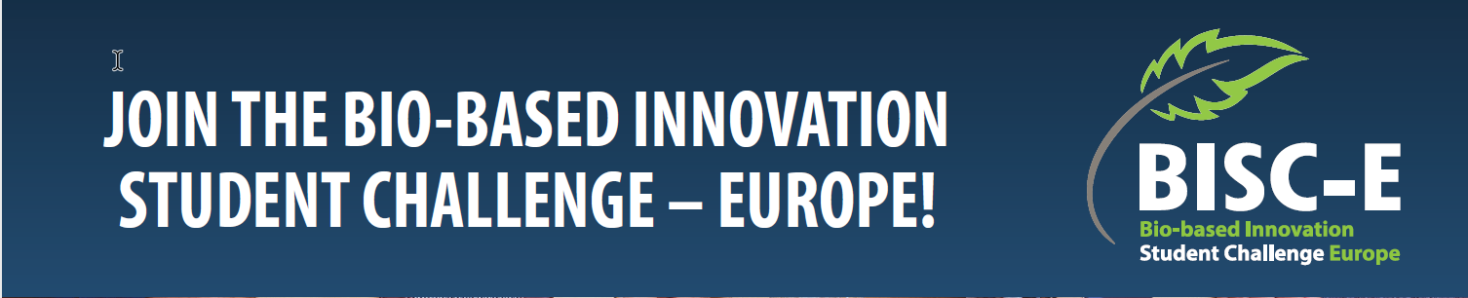

Join the Bio-based Innovation Student Challenge – Europe!

Are you ready to develop an innovative bio-based solution to help overcome hurdles standing in the way of a climate-neutral Europe? The Bio-based Innovation Student Challenge – Europe (BISC-E) invites students to design solutions in a multidisciplinary team and compete at national and international levels. Are you up to the challenge? Register with the National Coordinator in your country now!

The challenge
Develop an innovative bio-based product or process to help resolve technological, environmental, or societal challenges that could become part of the bio-based industry and the bioeconomy. Build your business case in a multidisciplinary student team. Present its benefits and your entrepreneurship to experts from industry and academia. The experts will judge your business case on technological excellence, sustainability and environmental performance, and economic feasibility.

Who can take part?
BISC-E is open to graduating students at universities of Applied Sciences and research universities. First-year PhD students can be part of a student team provided their current level is comparable to others within the European Qualification Framework, and the overarching framework of qualifications of the European Higher Education Area. It is highly advisable that the teams include students from different disciplines, including STEM (science, technology, engineering, mathematics) disciplines. Team members can be enrolled at different universities.

Who is the winner?
Participating in BISC-E makes you a winner thanks to the valuable experience you gain through collectively, in a multidisciplinary team, creating solutions for a sustainable future. And above all, the climate and the environment will be the ultimate winners!
If your team becomes the national BISC-E winner, you will be invited to represent your country in the European final.

The overall timeline:

31 March | Deadline for Team registration
1st week of April | Info day for registered Teams
19 May | Lithuanian Teams final
Autum 2023 | European final

